CO1 - ASSESSMENT TOOL
OUTPUT PREDICTION

NAME:M.CHARUMATHI
ROLL NO : 192524198
COURSE CODE : CSA0307
COURSE NAME : DATA STRUCTURES
SUBMITTED DATE : 24/JULY/2026
PROGRAM 1: Reverse an array elements
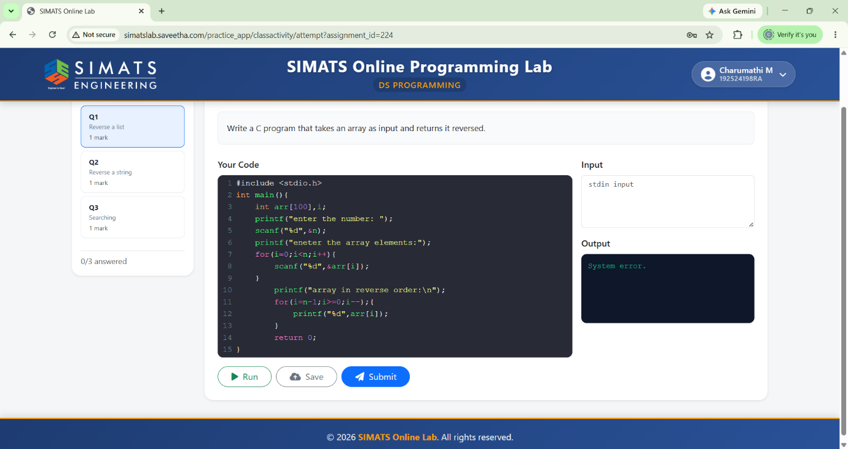
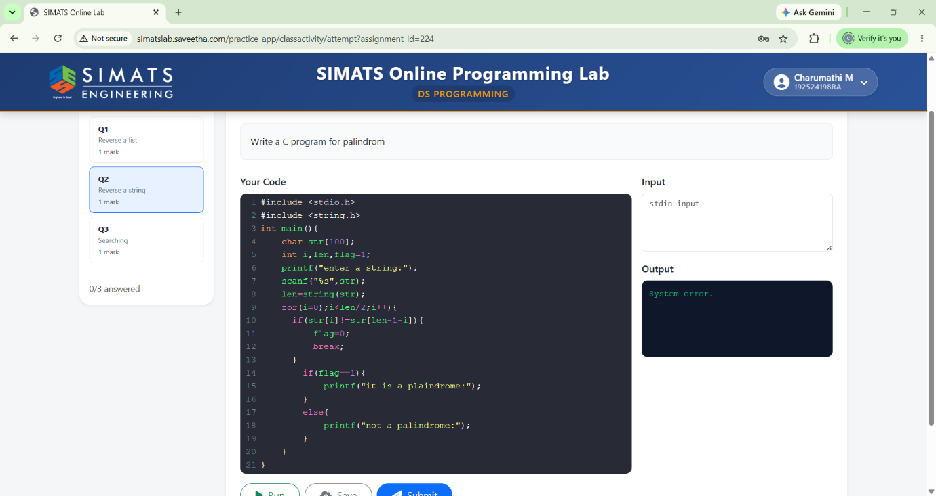
PROGRAM 2: Palindrome
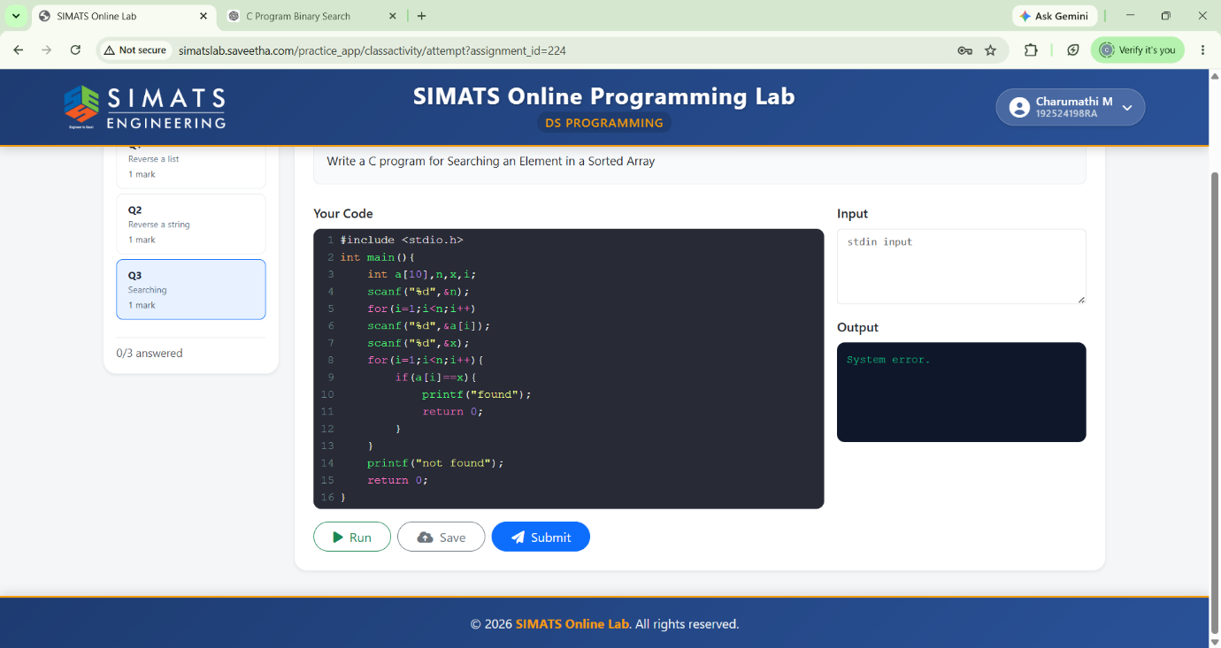

PROGRAM 3: Sorted Array

